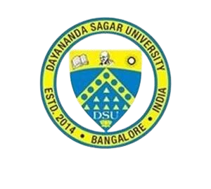

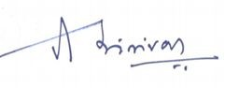

OF PARTICIPATION

IS PRESENTED TO:

Mr/Ms. Chandana C P

For participating in the Workshop on React JS organized by

Department of Computer Science and Engineering in association with Full Stack Development Club

**Dr. Girisha GS**

CHAIRPERSON CSE

**Dr. Srinivas**

DEAN SOE, DSU

# Dayananda Sagar University

School of Engineering, Innovation Campus, Kudlu gate signal, Hosur Main Road, Bengaluru-68

# Department of Computer Science and Engineering

in association with

Full Stack Development Club

**Workshop on React JS**

Date : 7th, 8th, 9th May 2022

CERTIFICATE